DSA 0601 - Data handling and visualization
Set 11 - Product Category Analysis

- Funnel Chart for Sales by Product Category
Code:

library(ggplot2)

products <- data.frame(
Category = c("Electronics", "Clothing", "Appliances"),
Sales = c(50000, 35000, 40000)
)

products <- products[order(products$Sales, decreasing = TRUE), ]

ggplot(products, aes(
x = reorder(Category, Sales),
y = Sales
)) +
geom_bar(stat = "identity", width = 0.7) +
geom_text(
aes(label = paste0("$", format(Sales, big.mark = ","))),
hjust = -0.1
) +
coord_flip() +
labs(
title = "Sales Funnel by Product Category",
x = "Product Category",
y = "Sales ($)"
) +
theme_minimal()

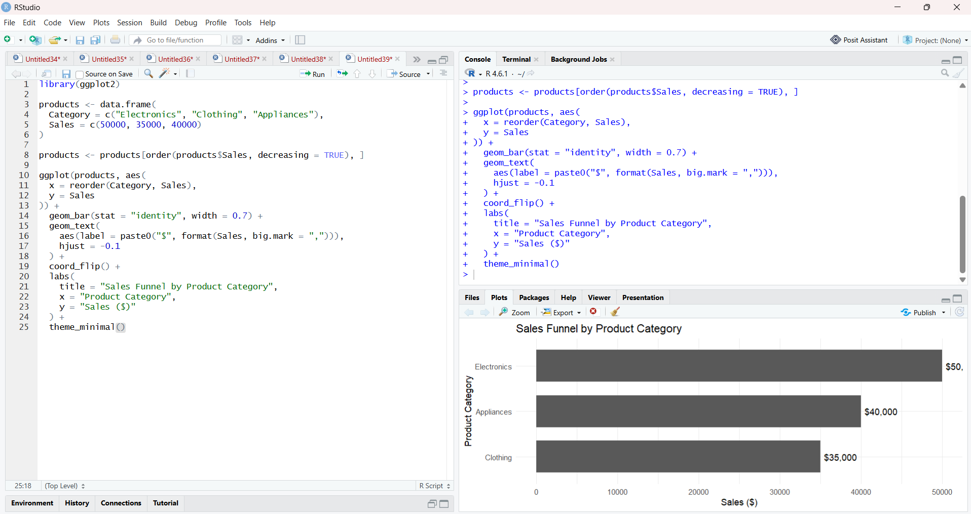

- Table of Product Category Sales
Code:

products <- data.frame(
Category = c("Electronics", "Clothing", "Appliances"),
Sales = c(50000, 35000, 40000)
)

print(products)

library(knitr)

kable(
products,
caption = "Product Category Sales Data",
col.names = c("Product Category", "Sales ($)")
)

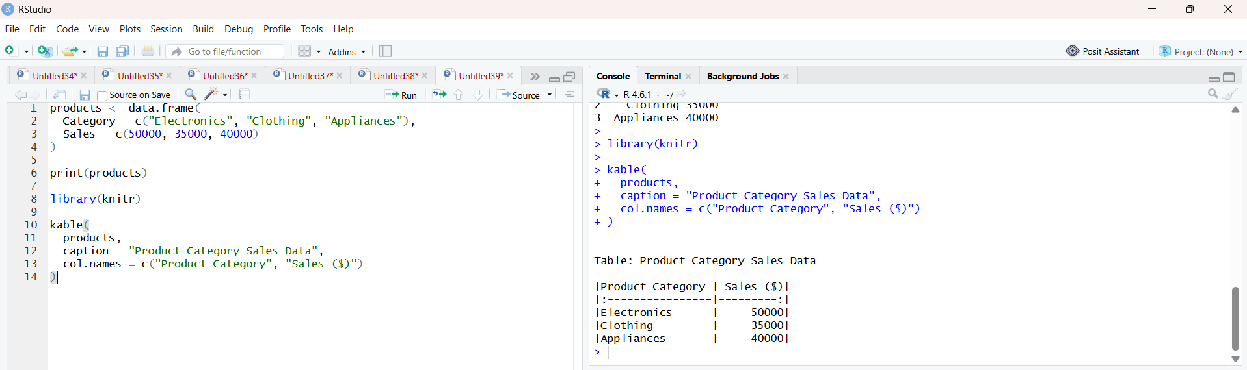

- Prepare Data for Tableau Dashboard
Code:

products <- data.frame(
Category = c("Electronics", "Clothing", "Appliances"),
Sales = c(50000, 35000, 40000)
)

write.csv(
products,
"product_category_sales.csv",
row.names = FALSE
)

print("CSV file created successfully.")

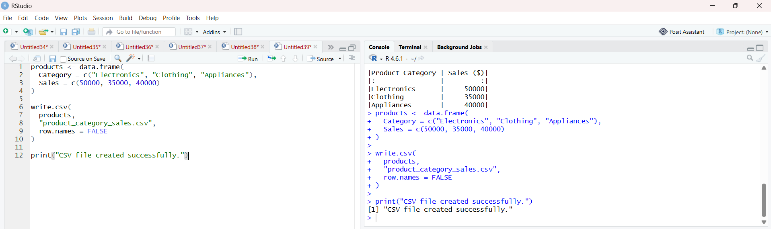

- Pie Chart for Sales Distribution
Code:

library(ggplot2)

products <- data.frame(
Category = c("Electronics", "Clothing", "Appliances"),
Sales = c(50000, 35000, 40000)
)

products$Percentage <- products$Sales / sum(products$Sales) * 100

ggplot(products, aes(x = "", y = Sales, fill = Category)) +
geom_bar(stat = "identity", width = 1) +
coord_polar("y") +
geom_text(
aes(
label = paste0(
"$", format(Sales, big.mark = ","),
"\n", round(Percentage, 1), "%"
)
),
position = position_stack(vjust = 0.5)
) +
labs(
title = "Sales Distribution by Product Category",
fill = "Category"
) +
theme_void()

